**Agenda Item X (x): SADC VSAT2 Upgrade Progress Report**

*(Presented by ATNS)*

|  |
| --- |
| **SUMMARY**  This working paper discusses the progress made to date in respect of the upgrade of the SADC VSAT Network and certain implications that have been identified. |
| **References:**   * Report of the 12th SADC Supervisory Board meeting |

1. **Background**
   1. At the 12th SADC Supervisory Board meeting it was agreed that the state of art ND Satcom MF-TDMA technology will be used for the network upgrade. The equipment is capable of providing connectivity for existing legacy application as well as the planned ICAO IP based applications e.g. AMHS.
   2. The SADC VSAT2 & NAFISAT upgrade project were split in two parts:

Phase 1: Included the equipment acquisition of the SkyWAN IDU7000 MF-TDMA technology platform from ND Satcom; and

Phase 2: The appointment of a local contractor for the

* Delivery;
* conducting of site surveys;
* drafting of the site upgrade specifications;
* physical installation of the upgrade equipment; and
* refurbishment of equipment (not part of the upgrade)

ATNS participated and managed the above tasks and was further responsible for:

* final setting-up;
* commissioning of the terminal equipment;
* transfer of operation to the upgraded network; and
* training of technical staff from each country.

Phase 1 of the project was largely on time but challenges were experienced in the Phase 2 of the upgrade project, which have resulted in delays of the initially committed commissioning timeframe. However the current network continued to provide safe and reliable services to the users.

1. **Discussion**
   1. **Implementation Schedule Timeline**
      1. The initial timeline for the implementation of the upgrade is shown in Diagram A in Attachment A, which was presented to the pervious SADC Supervisory Board. In summary it indicated the high level phases of the project with completion of the:

* Equipment manufacture by 26 February 2016;
* Completion of Installation by September 2016

Diagram B (Attachment A), shows the actual implementation time, which by comparison shows the delays for the:

* Equipment manufacture by 11 March 2016: 10 working days; and
* Completion of Installation by 16 March 2017: 143 working days.
  + 1. Considering the delays it must be stated that SADC VSAT 2 and NAFISAT needed to be upgraded at the same time because of the interconnectivity and the utilization of the main management centre in Johannesburg and the standby in Entebbe. Secondly, to prevent the need to retain any obsolete equipment the objective was to transfer all the sites at the same time. Thirdly, it was also assumed that all SADC VSAT2 and NAFISAT sites will be accessible to carry out the site surveys, delivery and upgrade installations. To provide an overall picture of the project and delays experienced, this report covers the upgrade of both networks.
  1. **Installation and Commissioning Schedule**

The installations work were completed during Calendar Week 10 (6 to 10 Match 2017), as shown in Attachment B/1. There are a number of reasons for the delay of 143 working days. The most important reasons are listed below.

* + 1. **Access to Sana’a and Saudi Arabia**

The initial implementation schedule assumed that all sites will be accessible to do site surveys. During the project it became clear that Sana’a and Saudi Arabia would not be installed in time. At the NAFISAT Supervisory Board Meeting during 10 to 11 October 2016, a Realistic Scenario was presented where ATNS were allowed the opportunity conduct site surveys, delivery and installation of Sana’a and Saudi Arabia by the end of February 2017. It was decided that should this not materialise ATNS will proceed with the transition of services to the upgraded network at the end of February 2017.

* + 1. **Incorrect delivery of equipment**

The VSAT terminal for Somalia is situated in Nairobi, however due to an error by the shipper the upgrade equipment was delivered to Mogadishu. The equipment could not be recovered and although the shipper accepted responsibility for all additional costs incurred, it inevitably caused delays. ATNS had to implement a mitigation plan to minimise delays

* + 1. **Delivery time of equipment**

A number of States required inspections of the equipment at the OEM, the issue of licences for importation, etc. This caused delays in the case of the DRC and ATNS also had to introduce mitigation plans to limit the delays.

* + 1. **Obtaining of Letters of Invitation**

Although this was mostly due to communication and administrative issue in most cases, it caused delays for specific installations.

* 1. **Transition of Services to the Upgraded Networks**

Transition from the old network was conducted on 16 March 2016. As mentioned previously both the SADC VSAT2 and NAFISAT networks have been upgraded simultaneously. This was required to ensure interconnectivity between the two networks i.e. between Johannesburg, Dar es Salaam, Plaisance, Antananarivo, Kinshasa, Kigali (in SADC), and Khartoum, Nairobi, Entebbe, Victoria (in NAFISAT).

The transitions were scheduled to take place from 18h00 – 20h00 and 20h00 and 24h00 GMT to minimize service interruption. Both networks were completed during the scheduled times.

* + 1. **Present state of affairs**

Attachment B/2 shows the state of transition as on 20 March 2017. It only indicates the circuits where problems are experienced (29 in total). The other circuits have all been successfully transferred (103).

Of the 29 circuits 8 will be transferred when Kigali is completed on 31 March 2017. Another 7 circuits will be transferred when the solution for the registration of the new frequencies for Mauritius has been resolved. The remaining 14 circuits are due to technical problems that will be resolved as soon as possible.

* + 1. **Conclusion of Transition**

The majority of circuits have been transferred successfully on 16 March 2017. It should be noted that services for the circuits that have not been transferred will continue to operate on the old network until the above-mentioned issues are resolved.

* 1. **Retention of interconnectivity with AFISNET**

**The SADC VSAT2 sites that interconnect with AFISNET are indicated in Attachment C (SADC highlighted in yellow)**

These circuits were retained in the upgrade. AFISNET has not upgraded their network and consequently the Datum MCPC (SCPC) modems and obsolete Memotec modems had to be retained at the SADC VSAT2 sites.

The risk of maintaining the obsolete Memotec equipment used in the SADC network will be mitigated through the number of additional Memotec units that will be available after the upgrade.

Additionally ASECNA has indicated that they are planning to upgrade all their AFISNET Memotec equipment with NetPerformer devices. The upgrade of the AFISNET modems is subject to a decision by the AFISNET Satellite Network Management Committee (SNMC/23).

* 1. **Training of SADC & NAFISAT Technical Personnel**

The ATNS Training Academy was upgraded and new training material developed based on the new ND Satcom SkyWAN IDU7000 modem and NetPerformer Frame Relay Access Device (FAD).

The initial detailed training of technicians from the SADC VSAT2 and NAFISAT states commenced on 20th June 2016 and courses will continue until all States have been trained. The States that have received training to date are shown in Attachment D. The remaining States will be hosted in future courses starting in April 2017.

In addition all technicians have received basic on-site training during the installation phase. This training ensured that the transition from the old to the new upgraded network was accomplished without any significant interruptions in the services provided.

* 1. **Additional work required by States**

In SADC VSAT2 three States required the relocation of their terminals in view new development of their aviation infrastructure, namely Mozambique (Maputo), Swaziland and Kinshasa. This was additional work required over and above the work scheduled for the upgrade.

It should be noted that the cost of this additional work was carried by the individual States. Because of the delay with the upgrades at some sites, and the resulting delay in the transition of the networks, the work at these three sites was done as part of the upgrade and did not delay the project as a whole.

1. **Implications**

The following implication should be mentioned as a result of the sites that were not upgraded as part of the transition of the two networks.

* 1. The problem of sites that were not upgraded as part of the transition of the two networks, as mentioned in paragraph 2.3.1 and Attachment B/2, are of a temporary nature that will be resolved as soon as possible.
  2. Services will not be interrupted since ATNS has sufficient Memotec and IDU5000 equipment to continue with the maintenance of the SADC and NAFISAT terminals.
  3. It should be mentioned that an amount of satellite spectrum will have to be retained for the old network. The optimization of the satellite spectrum can therefore not be completed until all the terminals in SADC and NAFISAT have been transferred to the new network. For the SADC VSAT2 sites this is not foreseen as a risk. However Sana’a and Saudi Arabia in NAFISAT could still be a problem for some unknown time. This risk of late upgrade of these sites will have to be discussed and may have to be referred to ICAO for a solution.

1. **Recommendations**

It is requested that:

a) The meeting take note of the progress made in respect of the upgrade of the SADC VSAT2 network.

b) Take note of the implication in paragraph 3.3, foreseen as a result of continued operation of both the old and the upgraded networks.



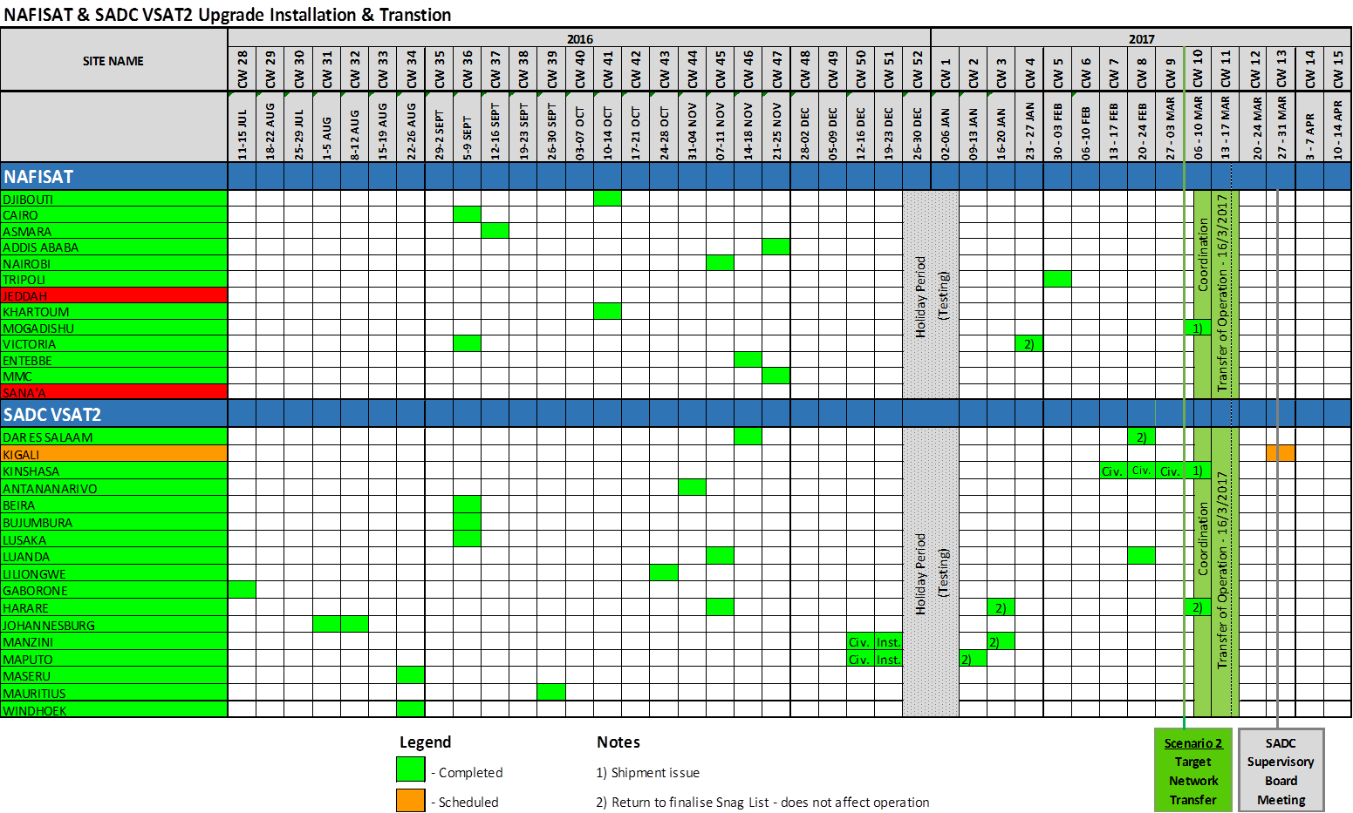



|  |  |  |
| --- | --- | --- |
| **AFISNET Circuits** | | |
| **NAFISAT & SADC Terminals connected to AFISNET** | **AFTN** | **ATS/DS** |
| Tripoli | Niamey  N'Djamena | Niamey  N'Djamena |
| Khartoum | N'Djamena | N'Djamena  Brazzaville |
| Addis Ababa | Niamey |  |
| Nairobi | Brazzaville |  |
| Luanda | Brazzaville  Accra | Brazzaville  Accra  Abidjan  Dakar |
| Kinshasa | Brazzaville | Brazzaville |



