

SADC VSAT III
FORECAST
FOR THE PERIOD
ENDING 31 MARCH 2017
Table of Contents
1. introduction 3
2. detailed analysis 3
2.1. Revenue 3
2.2. Total Operating Expenses 4
2.2.1. Salaries and Related Costs 4
2.2.2. Travel Expenses 4
2.2.3. Telecommunication Expenses 4
2.2.4. bad debt Expenses 4
2.2.5. Electronic Maintenance 5
2.2.6. network Management fees 5
2.2.7. OTHER OPERATIONAL EXPENSES 5
2.2.8. Overhead Expenditure 5
3. NET Funding 5
4. rECOMMENDATION 6
5. Statement of Financial position 7
6. CASH FLOW statement 8
7. ANNEXURE A: DEBTORS AGE ANALYSIS 9

introduction
This report outlines the forecasted performance for the period under review (year ending 31 March 2017).

The forecasted information is based on the actual 11 months data to 28 February 2017 extrapolated to the full financial year.

detailed analysis
The forecasted 31 March 2017 results are summarized below.

Table 1: Statement of Financial Performance
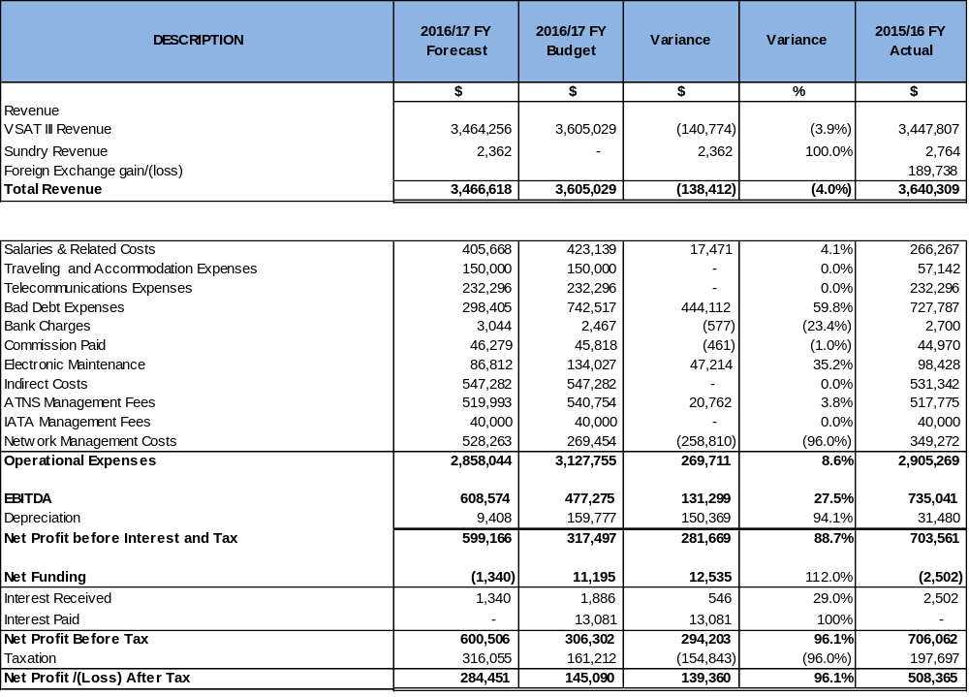

Revenue
Overall, total revenue of $3.467m is 4.0% lower than the budget due to the actual FIR’s being slightly less than the budget. FIR’s are forecasted at 360,860 whereas the budget had assumed 375,524.
Sundry revenue is made up of bad debts recovered.

The following graph depicts the FIR’s for the period under review compared to the 2016 financial year.

Graph 1: FIR Crossing movements
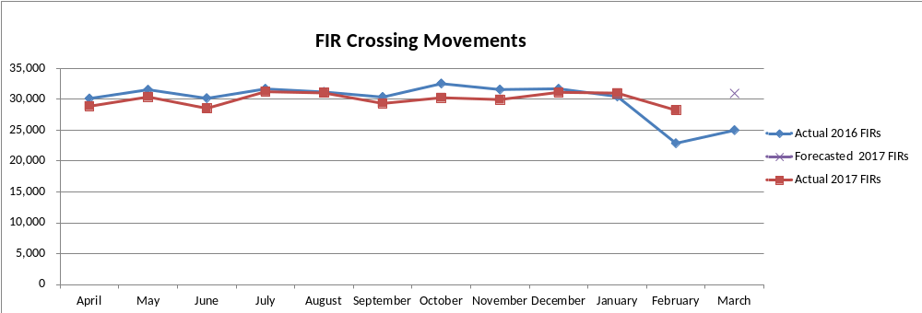

Total Operating Expenses
The total expenses before funding and depreciation are $269.7k (8.6%) below budget. The following are the major variances:

Salaries and Related Costs
Salaries and related costs are $17.5k (4.1%) below budget due to staff training initiatives that took place at less cost than initially anticipated.

Travel AND ACCOMMODATION Expenses
Travel and accommodation cover costs for the supervisory board meetings as well as member States training. It is forecasted that the entire budget will be utilized.

Telecommunication Expenses
Telecommunication expenses which include costs related to the spectrum are in line with the budget.

bad debt Expenses
Bad debts are forecasted at $444.1k (59.8%) below budget due to the stringent measures put in place to curb non-payment by debtors, including the following:
- effective and efficient collections;
- quarterly monitoring of the bad debts provision by ATNS & IATA task team; and
- refusal of service where applicable.

Electronic Maintenance
Electronic maintenance expenses are below budget by $47.2k (35.2%) mainly due to fewer equipment failures than anticipated. Included in the budget is a portion related contingent maintenance which covers unplanned corrective maintenance (emergencies) that may occur in addition to the planned routine maintenance. Certain maintenance is being undertaken as upgrades are performed.

network Management fees
Network management fees are 65% of net profit after tax, forecasted at $528.3k based on the agreement reached between ATNS and IATA.

OTHER OPERATIONAL EXPENSES
Other operational expenses include:
- Bank charges considered to be in line with the budget, although they are $0.6k above budget;
- Commission paid considered to be in line with the budget, although $0.5k above budget;
- Indirect costs which are in line with the budget;
- IATA management fees which are in line with the budget; and
- ATNS management fees are below budget $20.8k (3.8%) due to revenue being lower as a result of lower FIR’s.

Overhead Expenditure
Overhead expenditure (depreciation) is $150.4k (94.1%) below budget due actual depreciation being lower than anticipated as a result of to the delayed network upgrade.

NET Funding
The forecast net funding of $1.3k is interest earned on the bank account balance. Also, there are no borrowings.

rECOMMENDATION
It is recommended that the Supervisory Board notes the forecasted financial performance for the period ending 31 March 2017.

Statement of Financial position
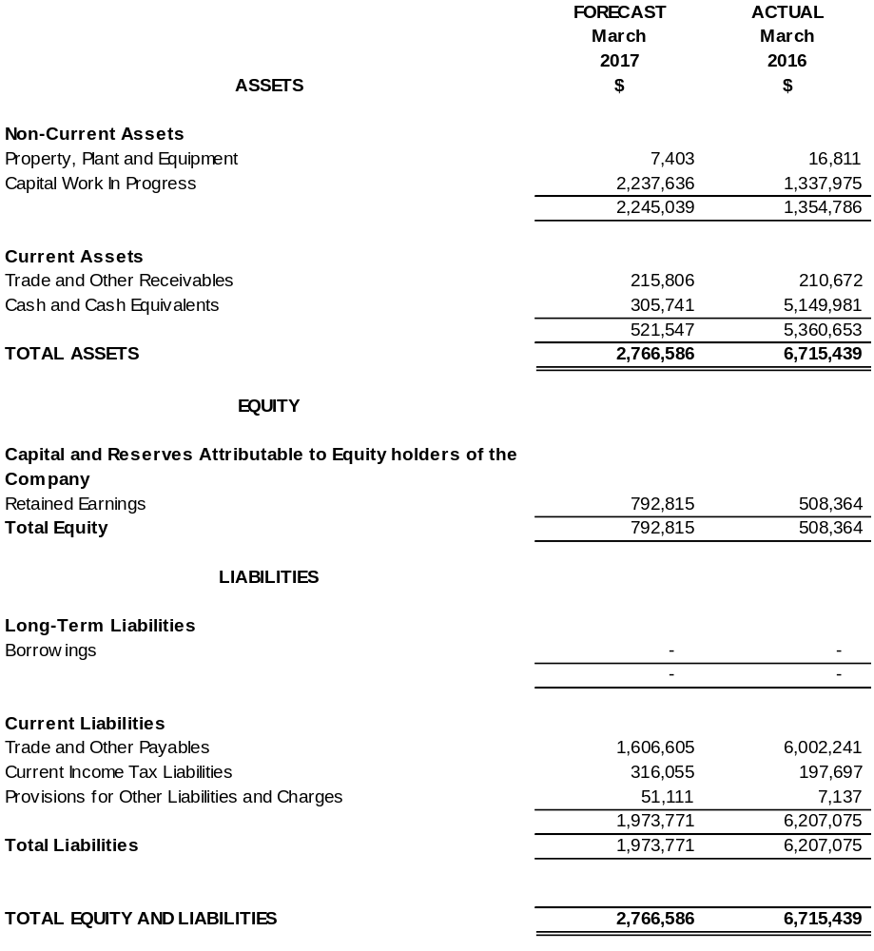

CASH FLOW statement
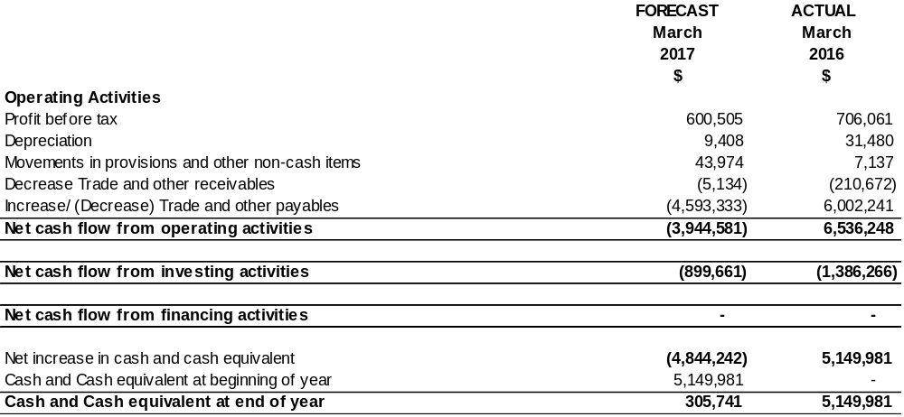

ANNEXURE A: DEBTORS AGE ANALYSIS


